Special thanks from the Southport High School FIRST Robotics Team!
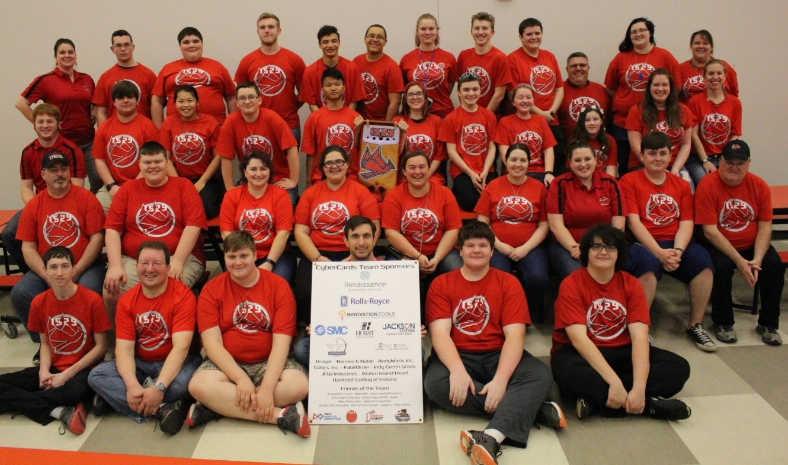
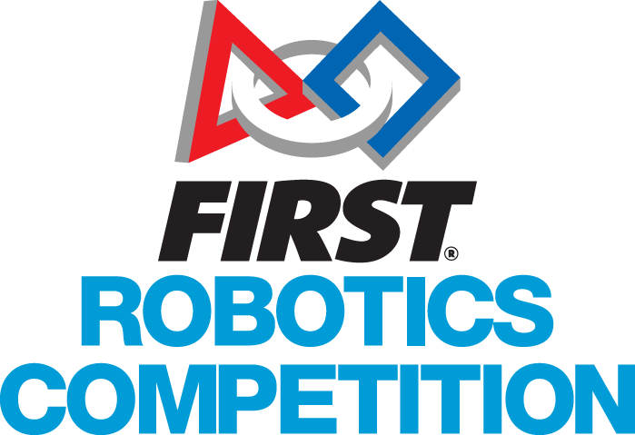
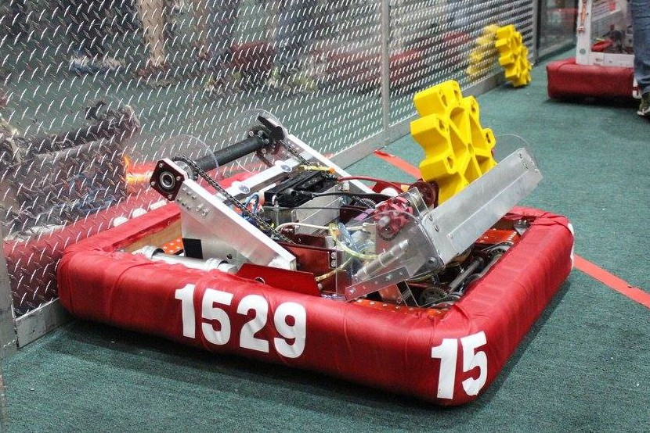
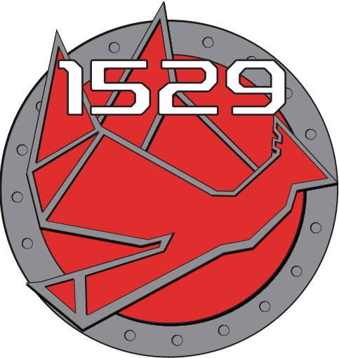

2017 Perry Meridian District Finalists
2017 Tippecanoe District - Team Spirit Award
2017 Perry Meridian District - Industrial Design Award

Sponsor Company
c/o Sponsor Contact
Mailing Address Line 1
Mailing Address Line 2
Mailing Address Line 3

FIRST Robotics Team 1529 – the CyberCards
971 East Banta Road,
Indianapolis, IN 46227

Dear Sponsor,
On behalf of a grateful team, I wish to thank you for your support in this year's game – Steamworks. FIRST Robotics can be overwhelming at times but we knew we could count on the support of our sponsors when we needed it. Your support helped us become the 2017 Perry Meridian District Finalists as well as winning the 2017 Industrial Design Award. We also had immense success coming together as a team winning the 2017 Tippecanoe District Team Spirit Award winners. We had a wonderful year and are looking forward to the future as we build our engineering program at Southport High School.

On behalf of the CyberCards, I want you to know that your continued support helps our team understand that FIRST is not only about robots; it's about learning in your pursuits. Thank you for helping us become self-confident leaders who are college or career ready.

Best Regards,

Name
FRC 1529
317-789-4800
frc1529@gmail.com

